Final Project: Pick a Project
Computer Science - Week 10
Oct 3, 2026 - Version 0.0.2
Please make sure to your UD email AND name is below. Unless your UD emails are included in this table, then you will not earn any points for this assignment when it is graded! Every person should submit their own individual worksheet.

Talk about each of the questions with a friend or our LLM (or both), but make sure the words you enter below are yours (with the obvious exceptions notwithstanding). Brainstorming is best done in full sentences, and the main goal here is brainstorming. It's worth reviewing the information in this series of pages in the Drafter documentation to gain a better understanding of the process.

Role | Name | Email
Developer (You) | Lizzie Tuel | etuel@udel.edu
Friend (optional)

Part 1: The Goal & Prior Implementations
- Identify the Goal: What specific goal are you trying to address? Think about your passions, hobbies, and academic interests. The latter are an excellent candidate to focus on. Some majors have suggestions listed below: these were provided by faculty in those departments. Other majors could consider a focus tied to a big final assignment in one of their recent courses in their major.
  - Majors in the Electric & Computer Engineering department may consider a steganography project that hides messages in images, and then retrieves those messages.
  - Biomedical Engineering majors may consider one of the following:
    - If you have started (or completed) the Cell/Tissue Design final project in BMEG100, design an organoid, which involves combining a cell type, biomaterial, and testing method. Have the website include a description and diagram of your design concept, a testing method, a needs statement, and an impact statement relevant to their organoid. Also include a link to a paper that supports your idea and a paragraph describing how that paper supports your design concept.
    - Otherwise, create a website related to your BMEG100 Lab Report 1, Cytoskeletal and Nuclear Staining Lab Report Guidelines, linked here (University of Delaware account required to access).
  - Chemistry and Chemical Engineering majors may consider the project below.
    - Create an automated chemistry assistant that takes balanced reaction equations, starting reactant masses, and a harvested product amount to determine the limiting reactant, theoretical yield, and percent yield based on principles from Chemistry 2e (OpenStax) — Chapter 4: Chemical Reactions and Stoichiometry. To avoid manually compiling atomic mass tables or writing custom string tokenizers, use the chempy library to parse molecular formulas into exact molecular weights and verify reaction stoichiometry against compound data from the NIH PubChem Database. The program outputs an organized breakdown of limiting reagent status, product yields, and remaining masses of unreacted species. Also use the heat of the reaction to determine if it is exothermic or endothermic, and compute the heat flow per mole of the product.
I am going to base my project on a book tracker app that also provides recommendations based on what the person has already read and enjoyed.

- Prior Implementations: Search the internet. What existing tools or websites currently attempt to address it?
There are both physical and digital trackers with the physical ones being things such as bullet journals or reading charts and the digital ones being apps such as goodreads or libby.

- Your Implementation: Briefly describe the legitimate purpose or functionality of your site. How would you want this web application to be used?
I want this app to be used as a tracker to see all of the books the person has read, maybe even notes on what they thought, and give them realistic book ideas for their future reads.

Part 2: The Input-Process-Output (IPO) Model
Think about the fundamental flow of your program.
- The Core Goal: Every program has three main phases: taking input, processing data, and presenting output. In one sentence, what is the ultimate goal your program will accomplish for the user? Be specific and use CS1 concepts.
The ultimate goal of this program is for a user to input the book they read and their feedback on the book, the program calculates and interprets the feedback, and outputs a new recommendation while storing the previous input.

- Input: What specific information will the user need to provide to your program? (e.g., a city name, a numerical budget, a list of hobbies).
The title of the book and their feedback on it.

- Processing: At a high level, how will the computer manipulate or evaluate that data? (e.g., calculate the average, filter out options that are too expensive, compare the input against a database).
The computer will sort through the feedback and match genres and ratings as well as storing the input the user inputted.

- Output: What will the user get back? (e.g., a recommendation, a calculated safety factor, a formatted schedule).
The user will get back a recommendation on a book that fits their preferences.

Part 3: Data Abstraction
Identify the "nouns" of your problem.
- Representing Reality: Abstraction is the process of representing the real world inside a computer by ignoring unnecessary details. What are the core "things" (nouns) your program needs to track? (e.g., If building a recipe app, the nouns are "Recipe" and "Ingredient").
Book Titles, Feedback, Rating, Recommendations

- Identifying Properties: For the most important "thing" you listed above, what 3 to 4 specific details do you actually need to solve your problem, and what details will you abstract away?
  - Details I need: (e.g., Ingredient name, weight, cost)
  - Details I will ignore: (e.g., Ingredient color, brand, expiration date)
Book Title - Details I need: name of book, genre of book, rating of book, length of book; Details I will ignore: publisher of book, book cover, cost of book

Part 4: Challenges, AI Strategy, & Goals
- Difficulties: What parts of this project seem the most difficult or technically complex?
The most difficult part seems to be storing all of the inputted books in a way that allows the user to still see them even after inputting new titles.

- Coding Strategy: If you will be using an LLM to help code, how will you ensure you understand the generated code and avoid "hallucinations" or "shallow learning" (copying without understanding)? If you won't be using an LLM to help code, this project might take about 4 hours a week to complete, so list each of the days and times in which you work on the project.
I will be using an LLM to help code but in order to ensure I understand what is going on I will ask deeper questions and have the LLM walk me through the code rather than doing it all for me.

- Goals: What is your ultimate goal for this project? (e.g., Impress the graders with a creative UI, build something I can use in my other classes, learn Drafter deeply).
Understand Drafter better and create something that could be used to give someone a recommendation they have never heard of.

Part 5: Research & Brainstorming Conversation
Have a conversation with a Generative AI tool (like ChatGPT or Claude) OR a friend about your project idea. Do not ask for code. Instead, use the AI/friend as a sounding board to research your problem.
- The Initial Prompt/Question: Ask the AI or your friend to help you brainstorm. (e.g., "I want to build a simple web tool to help students track their study hours. What are 3 common problems students face when tracking their time, and what are 3 simple features a basic tool should have?"). Paste your prompt below:
I want to build a simple web tool to help people track their books they have read and provide them with new recommendations. What are 3 common problems people face when tracking their books, and what are 3 simple features a basic reading tracker and recommender should have

- The Response: Briefly summarize the best ideas the AI or your friend suggested. What existing solutions or prior apps did they mention?
3 common problems people face are forgetting which books they’ve read, having trouble choosing their next book, and losing track of their reading progress. 3 features my web tool should have is a personal book library, personalized book recommendations, and a reading progress dashboard.

- The Pushback: You must reply to the AI/friend to narrow the scope when it's over-ambitious. Pick the most complex feature they suggested and explain why it is too complicated for an introductory programming project. Ask them for a simpler alternative. Paste your response here:
Instead of doing recommendations based on one specific title, I could produce many different recommendations for the person to pick between.

- Reflection: Based on this conversation, how has your project idea changed or become more focused?
It has become more focused because now I know exactly the problems I want to make a solution for and I know three ways I can implement ideas to fix these.

Part 6: Resource Planning
- What resources will you use if you get stuck?
I will use an LLM and if I don’t understand it I will ask a friend and if I am still confused I will ask a TA.

- If your LLM provides code that causes a Drafter or Bakery error, or if you run into a problem during deployment, what is your step-by-step debugging plan to resolve it?
I will go through the code to see if there are any issues I can see or identify. If not, I will ask the LLM. If the LLM is confused I will go to a TA for help.

Part 7: LLM Conversation
If you used an LLM in any part of this work, copy and paste every part of that conversation below. Otherwise, you may be given a zero for the assignment. Obviously, these words will not all be yours, and this is the exception to the requirement at the top of this assignment that all responses be in your own words. If you did not use an LLM to assist you in this assignment, simply say so below.
I want to build a simple web tool to help people track their books they have read and provide them with new recommendations. What are 3 common problems people face when tracking their books, and what are 3 simple features a basic reading tracker and recommender should have
For your computer science final project, a reading tracker and book recommender is a great idea because it solves a real problem and lets you demonstrate CS1 concepts like user input, conditionals, lists, and data processing.

3 common problems readers face
- Forgetting which books they've read. People may forget a book's title, whether they finished it, or what they thought about it.
- Having trouble choosing their next book. With so many books available, readers may struggle to find something that matches their interests.
- Losing track of their reading progress. Readers may forget which books they are currently reading, how far they've gotten, or which books they want to read next.

3 simple features your web tool should have
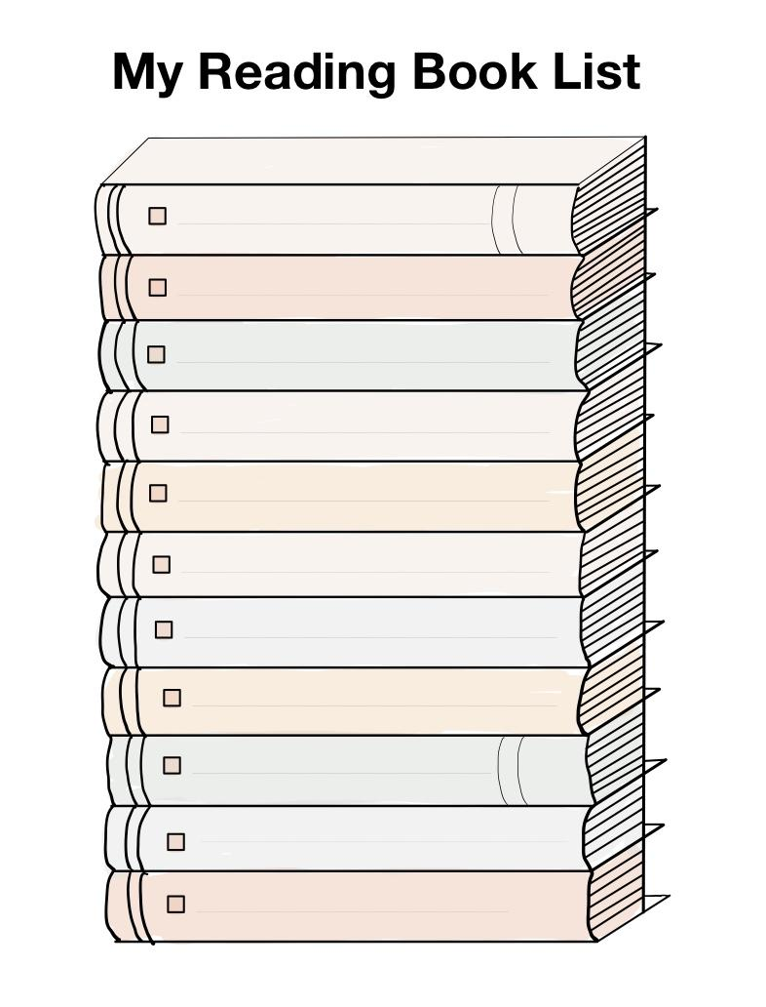
1. Personal book library
Let users add books by title and author, mark each book as Want to Read, Currently Reading, or Finished, and optionally give it a rating.
CS1 concepts: user input, lists, variables, and updating data.

2. Personalized book recommendations
Ask users to choose their favorite genres, such as fantasy, mystery, romance, or science fiction. Then use conditional statements to recommend books that match their preferences.
CS1 concepts: conditionals, comparisons, and filtering lists.

3. Reading progress dashboard
Display the number of books finished, the number currently being read, and the number on the user's reading wishlist.
CS1 concepts: counters, loops, calculations, and output.

How these features work together
Your program could follow this simple process:
1. Input
The user enters books, ratings, and favorite genres.
2. Process
The program stores book information, counts reading progress, and matches genres to recommendations.
3. Output
The user sees their book library, reading statistics, and personalized recommendations.
My recommendation: Start with these three features and keep the recommendations simple. You could create a predefined list of books with their genres and use if statements or loops to find matching books. That makes the project achievable while still demonstrating important programming skills.
A useful next step is to turn these features into a one-sentence project goal and a short list of requirements for your final project proposal.

For a book-tracker web tool, finding bugs in real flows is a helpful next step.
Ad
Ad options
Learn more
For the most complex feature of my web tool how can i make it a simpler alternative
For your reading tracker and book recommender, the most complex feature is probably personalized book recommendations, because you need a way to compare a user's interests with a list of books.
A simpler alternative is to create a genre-based recommendation system.

How to simplify the feature
Original, more complex feature
Recommend books based on a user's reading history, ratings, favorite authors, and similar readers' preferences.
Simpler alternative
Let users select their favorite genre, then display books from that genre using a predefined list.

Example of how it would work
- The user selects Fantasy from a dropdown menu.
- The program checks a list of books and finds the ones labeled Fantasy.
- The website displays the matching books as recommendations.
For example, your book list might contain Harry Potter, The Hobbit, and The Hunger Games, each with a genre. The program would display only books matching the user's selection.

Why this is a good choice for a CS1 project
- Input: The user selects a genre.
- Processing: A loop and conditional statements find matching books.
- Output: The website displays recommended titles.
You won't need artificial intelligence, complicated algorithms, or a large external database.
A good simplified feature requirement would be: “The program will recommend books by matching the user's selected genre to the genres stored in a predefined list of books.”
You can always add ratings or more personalized recommendations later if you have extra time.

Part 8: Submit
In Google docs, with this document open, please click on File > Download > Microsoft Word (.docx), and make sure you put that download somewhere you can find it again. Then, upload it to the Canvas assignment about selecting or brainstorming your final project.

When you're done with this assignment, review this page of the Drafter documentation to better prepare for the next step.

